**Lone Cabbage Reef Restoration Project: Oyster Sampling Protocol (Winter 2018-2019)**

This protocol is divided into two sections based on the type of question being answered. Even though transects will be used for each question, different methods will be used.

All transects will:

-Be randomly selected, but these same locations will be used each year of project

-Be used to count the number of live and dead oysters greater than 1 cm in height visible without moving substrate

-Be 15.24cm (6 inches) wide, but will vary with length

-Be divided into 2.5m increments

-Use the northern or western end as “0” with regards to transect/measuring tape start point.

-Have a PVC marker pole placed at each end to aid finding location in the future.

Examples of what transect work is like on the restored and surrounding reefs: Can you find the oysters?

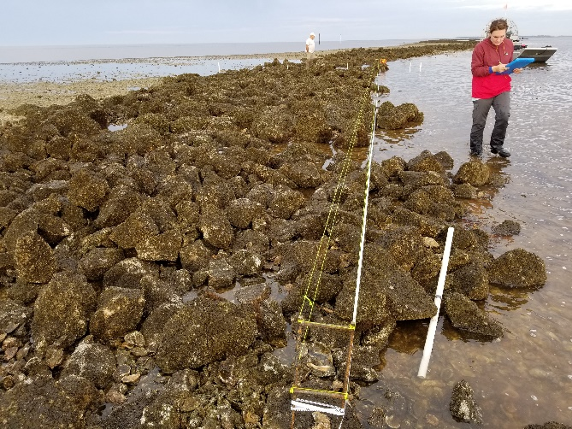 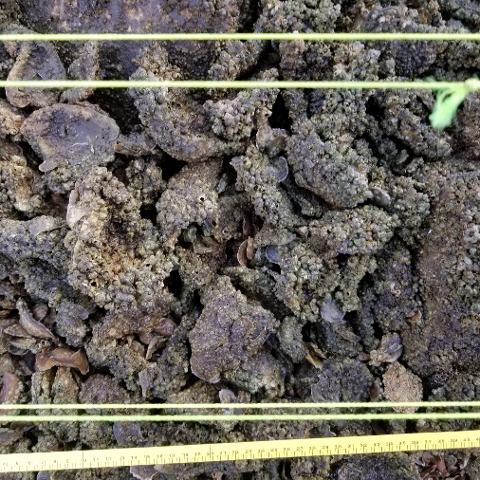

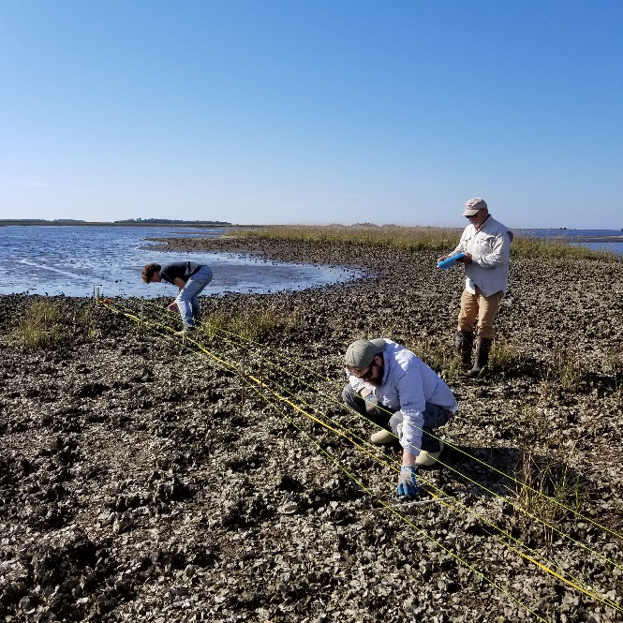 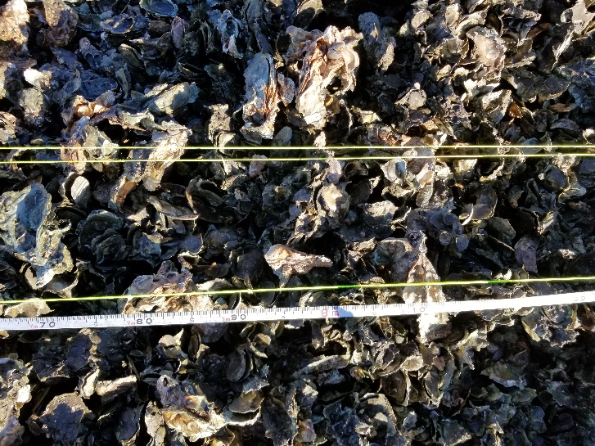

**QUESTION 1: Did rock addition change oyster abundance on LC reef?**

*Sample locations:* Old pilot project control plots (4)

*Number/Distribution of transects:* 18 (See Figures 1-5)

*Strata:* All closed to harvest/large rock

*Transect Length:* 22m

*Minimum crew size:*  3 people (1 recorder, 2 counters)

*Materials for each minimum crew:*

-Three 100m measuring tapes

-Two “H” rebar end-posts (sets transect width to 15.24cm)

-One roll of string

-Two pairs gloves

-Two pairs kneepads

-Two clickers

-Two sticks to demarcate 2.5m increments

-Clipboard with datasheets

-GPS with coordinates for old control plots

-Hand sledge hammer

*Protocol:*

1. Navigate to old control plot. Establish 2 western corner points of plot 22m apart parallel to reef.
2. The counters will set up transects:
   1. From northwest corner, extend tape measure across reef perpendicularly. Stop at 22m. This will create the north side of the old control plot.
   2. Repeat from the southwest corner to create south side.
   3. Refer to Figures 1-5 for old control plot and random 1.5m transect locations.

***NOTE: 1.5m intervals for transect locations start 0.5m from reef edge

* 1. At first transect set both “H” rebar end-posts at designated 1.5m interval.
  2. Create belt transect by wrapping string around tops of rebar endposts, ensuring string is on outside edge of rebar. The outside of the rebar endposts = 15.24cm/6 inches.
  3. Repeat step 2e, but wrapping string around endpost cross piece creating the lower belt transect.
  4. Run the third tape measure along transect, with “0” at the north end. This will be used to demarcate 2.5m intervals.

1. The recorder will review the data sheet while the transect is being established, ensuring the following data is collected:
   1. Date (YYYYMMDD)
   2. Time (24hr UTC format = 5 hours ahead of eastern time)
   3. Locality/Site/Bar/Station/Transect (see Table 1)
   4. Recorder/Counter (initials)
   5. Start/End GPS coordinates (UTM)
   6. Treatment (control/rocks)
   7. Count (live/dead)
   8. Datasheet count
   9. PHOTO: Take a photo of the datasheet and then take a photo of the transect from the south end facing north (due to blinding early morning sun).
   10. From a randomly chosen segment in each transect, the counter will measure the height (mm) of the first 10 oysters encountered.
2. Ideally one counter will count an entire transect and will start counting live and dead oysters in the 0-2.5m interval; proceeding until the end of the transect. If multiple counters on the same transect is most efficient, then split the transect accordingly and avoid “leapfrogging” intervals.
3. Pound a PVC post into the ground until only 1ft is exposed at each transect endpoint
4. Remove rebar end posts and repeat steps 2-7 for remaining transects
5. Repeat steps 1-7 for the remaining old control plots.

*Transects 5,8,13,15,18 were randomly chosen to be counted twice by different counters and use a separate datasheet.

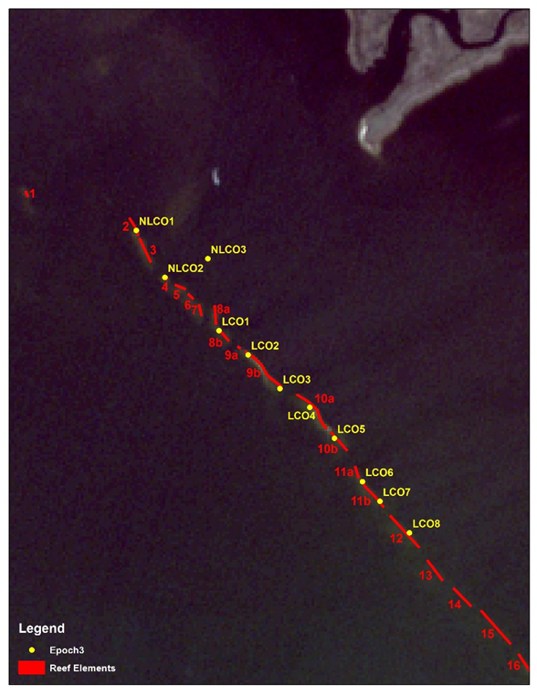

Figure 1: Old pilot project control plots were labeled LCO3, LCO4, LCO7, and LCO8 (yellow). New labeling scheme reflects reef element number (red). USE NEW LABELING SCHEME.

Table 1: List of options for Locality/Site/Bar/Station/Transect for both Questions 1 and 2:

|  |  |  |  |  |  |
| --- | --- | --- | --- | --- | --- |
| Question | Localities | Site | Bar | Station (Combine) | Transect |
| 1 and 2 | LC  (Lone Cabbage Reef) | O  (Offshore: not zero) | 2-22  (reef element #, may contain letter) | Example:  (LCO12 or LCO9C) | 1,2,3,…*i* |
| 2 | LC | N  (Nearshore) | 1,2,3,…*i* | Example:  (LCN2 or LCN3) | 1,2,3,…*i* |
| 2 | LC | I  (Inshore) | 1,2,3,…*i* | Example:  (LCI2 or LCI3) | 1,2,3,…*i* |
| 2 | BT  (Big Trout Creek) | I  (Inshore) | 1,2,3,…*i* | Example:  (BTI2 or BTI3) | 1,2,3,…*i* |
| 2 | LT  (Little Trout Creek) | I  (Inshore) | 1,2,3,…*i* | Example:  (LTI2 or LTI3) | 1,2,3,…*i* |
| 2 | NN  (No-name Creek) | I  (Inshore) | 1,2,3,…*i* | Example:  (NNI2 or NNI3) | 1,2,3,…*i* |

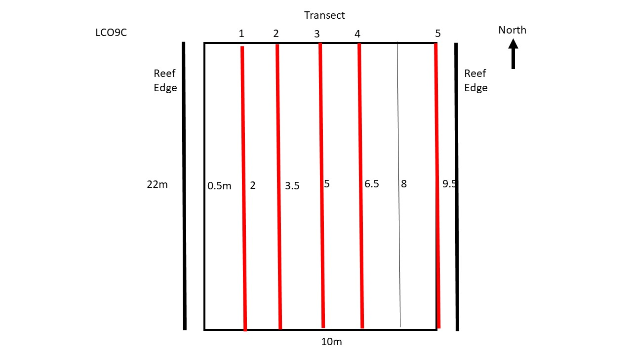

Figure 2: Transect distribution for LCO9C (previously LCO3). Red lines depict transects that will be sampled.

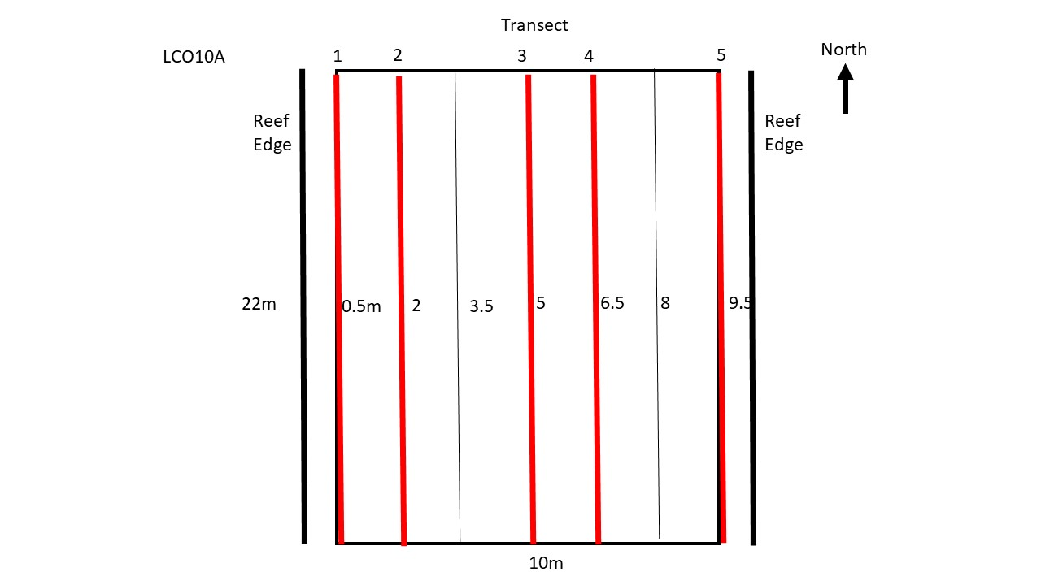

Figure 3: Transect distribution for LCO10A (previously LCO4). Red lines depict transects that will be sampled.

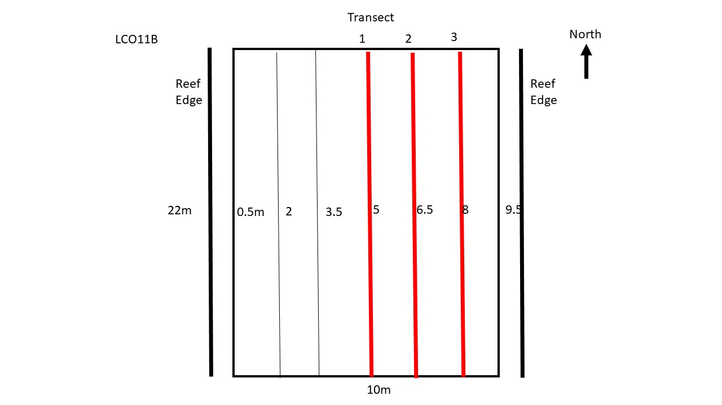

Figure 4: Transect distribution for LCO11B (previously LCO7). Red lines depict transects that will be sampled.

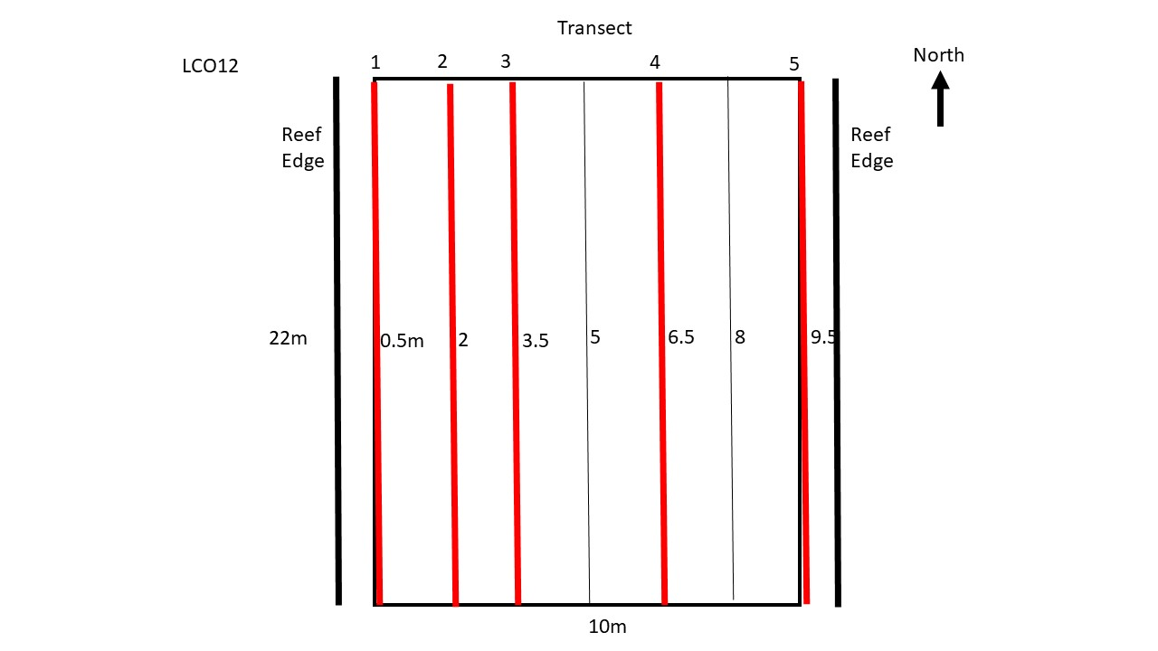

Figure 5: Transect distribution for LCO12 (previously LCO8). Red lines depict transects that will be sampled.

**QUESTION 2: Have wild reefs responded to LC Reef restoration?**

For this question the wild reef areas (LCN, LCI, NNI, LTI, and BTI) were digitized using Labins.org high resolution imagery collected in 2013. Wild reef areas were divided into two strata (Harvestable/Non-Harvestable), transects were randomly selected from a 2m x 2m grid overlaid with reef polygons. Previous sampling locations from Epoch 1 and spring 2018 were added. Lone Cabbage Reef (LCO) was divided into three strata (Large Rock Harvest/Small Rock Harvest/Small Rock No Harvest). Data were analyzed during initial sampling in winter 2018/2019 and additional transects were added as needed to improve power.

Table 1: Reef and transect totals by Locality and Site for Question 2.

|  |  |  |  |
| --- | --- | --- | --- |
| Locality | Site | # Bars (Reefs) | # Transects |
| Lone Cabbage | Inshore | 12 | 43 |
| Lone Cabbage | Nearshore | 9 | 9 |
| Lone Cabbage | Offshore | 19 | 23 |
| No Name Creek | Inshore | 4 | 5 |
| Little Trout Cr. | Inshore | 6 | 7 |
| Big Trout Creek | Inshore | 6 | 10 |
| TOTAL |  | 56 | 97 |

Table 2: Designated strata by station for Question 2.

|  |  |  |
| --- | --- | --- |
| Stations | Harvest Strata (open to harvest) | Rock Size |
| LCO2-12 | No | Large Rock |
| LCO13-16 | No | Small Rock |
| LTI, BTI, NNI, LCI1 and LCI7 | No | N_A |
| LCO17-22 | Yes | Small Rock |
| LCN, LCI2-6, LCI8-19 | Yes | N_A |

*Transect Length:* Variable

*Minimum crew size:*  3 people (1 recorder, 2 counters)

*Materials for each minimum crew:* Same as Question 1 except: 234 pvc marker posts needed

*Protocol:*

*WILD REEFS:*

1. Navigate to transect coordinates (Figures 6-16, Table 3)
2. The counters will set up transects:
   1. From north or west end of transect, extend tape measure across reef until the defined length is reached. This should coincide with the endpoint coordinates. Center transect with relation to tide if needed.
   2. Epoch 1 transects will follow their original orientation, Spring 2018 transects need established along long axis of reef, and Epoch 3 (new) transects will all be oriented north-south or east-west depending on the random draw
   3. Set both “H” rebar end-posts.
   4. Create belt transect by wrapping string around tops of rebar endposts, ensuring string is on outside edge of rebar. The outside of the rebar endposts = 15.24cm/6 inches.
   5. Repeat step 2d, but wrapping string around endpost cross piece creating the lower belt transect.
3. The recorder will review the data sheet while the transect is being established, ensuring the following data is collected:
   1. Date (YYYYMMDD)
   2. Time Start/End (24hr UTC format = 5 hours ahead of eastern time)
   3. Locality/Site/Bar/Station/Transect (see Table 1)
   4. Recorder/Counter (initials)
   5. Start/End GPS coordinates (UTM)
   6. Count (live/dead)
   7. Datasheet count
   8. PHOTO: Take a photo of the datasheet and then take a photo of the transect from the start point.
   9. From a randomly chosen segment in each transect, the counter will measure the height (mm) of the first 10 oysters encountered.
4. Ideally one counter will count an entire transect and will start counting live and dead oysters in the 0-2.5m interval; proceeding until the end of the transect. If multiple counters on the same transect is most efficient, then split the transect accordingly and avoid “leapfrogging” intervals.
5. Pound a PVC post into the ground until only 1ft is exposed at each transect endpoint, marking the start post (north or west end) with a metal tag inscribed with the station, and drill holes on the side facing the end post corresponding to reef/bar number (drill 3 holes in BTI3, LCN3, etc)
6. Remove rebar end posts and repeat steps 1-5 for remaining transects

*LONE CABBAGE OFFSHORE:*

1. Navigate to the LCO coordinates in Table 3. Each row represents the northern end of a 22m reef segment. The “TRANS_NUM” Column indicates how many 22m transects parallel to the reef will be located in each segment and the distribution of transects within each segment (Figure 17) will be determined by random draw.
2. Follow steps 2-6 of the Wild Reef Protocol Above

*Approximately 1/5 of the transects were counted twice to determine detection differences.

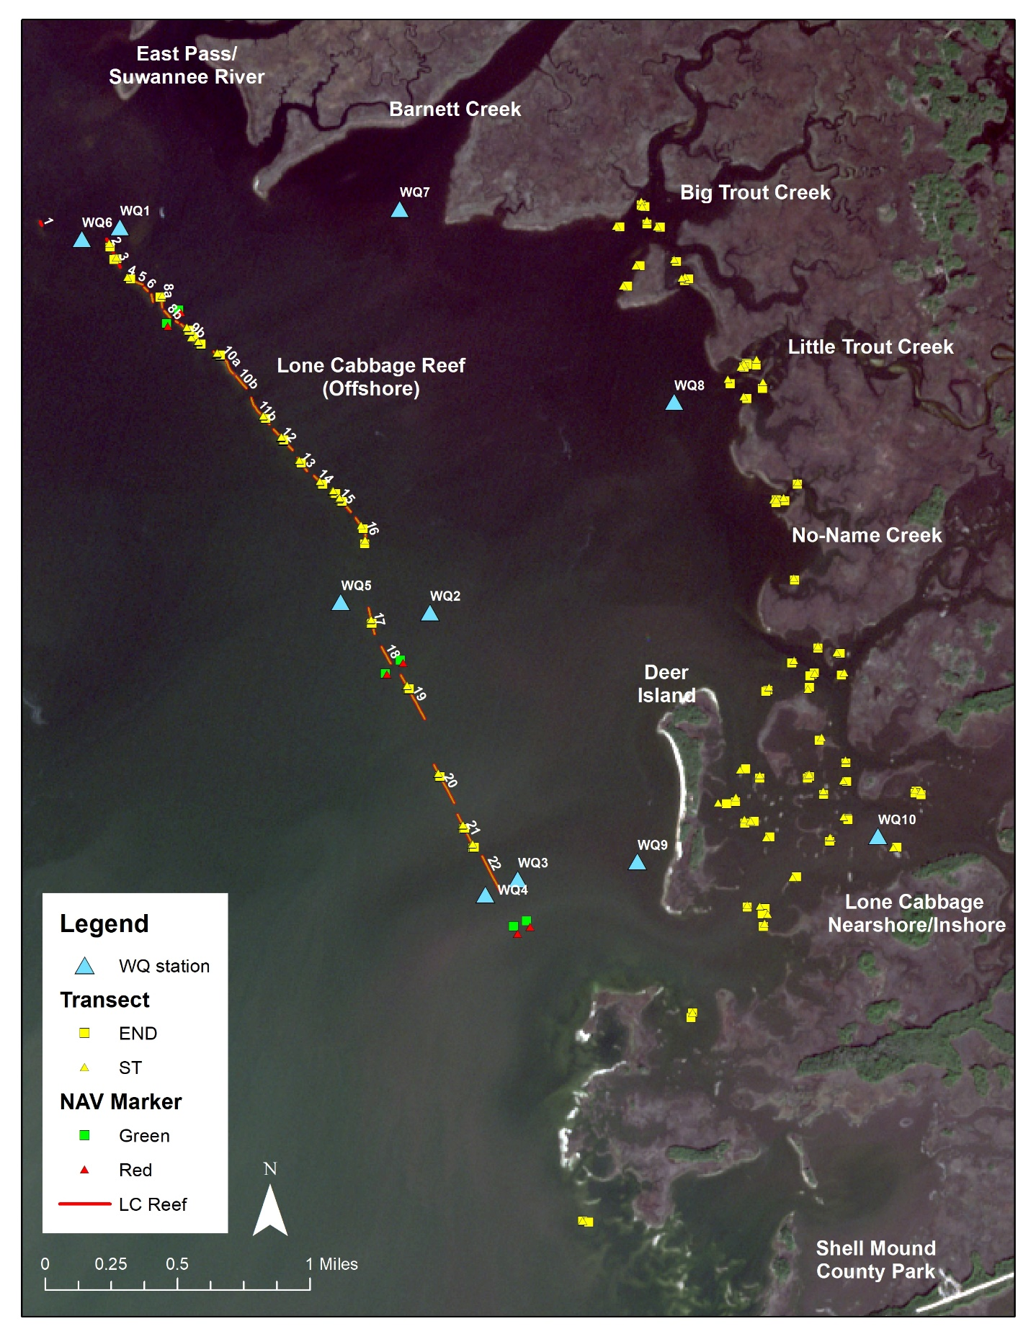

Figure 6: Final question 2 transect distribution for the entire project area.

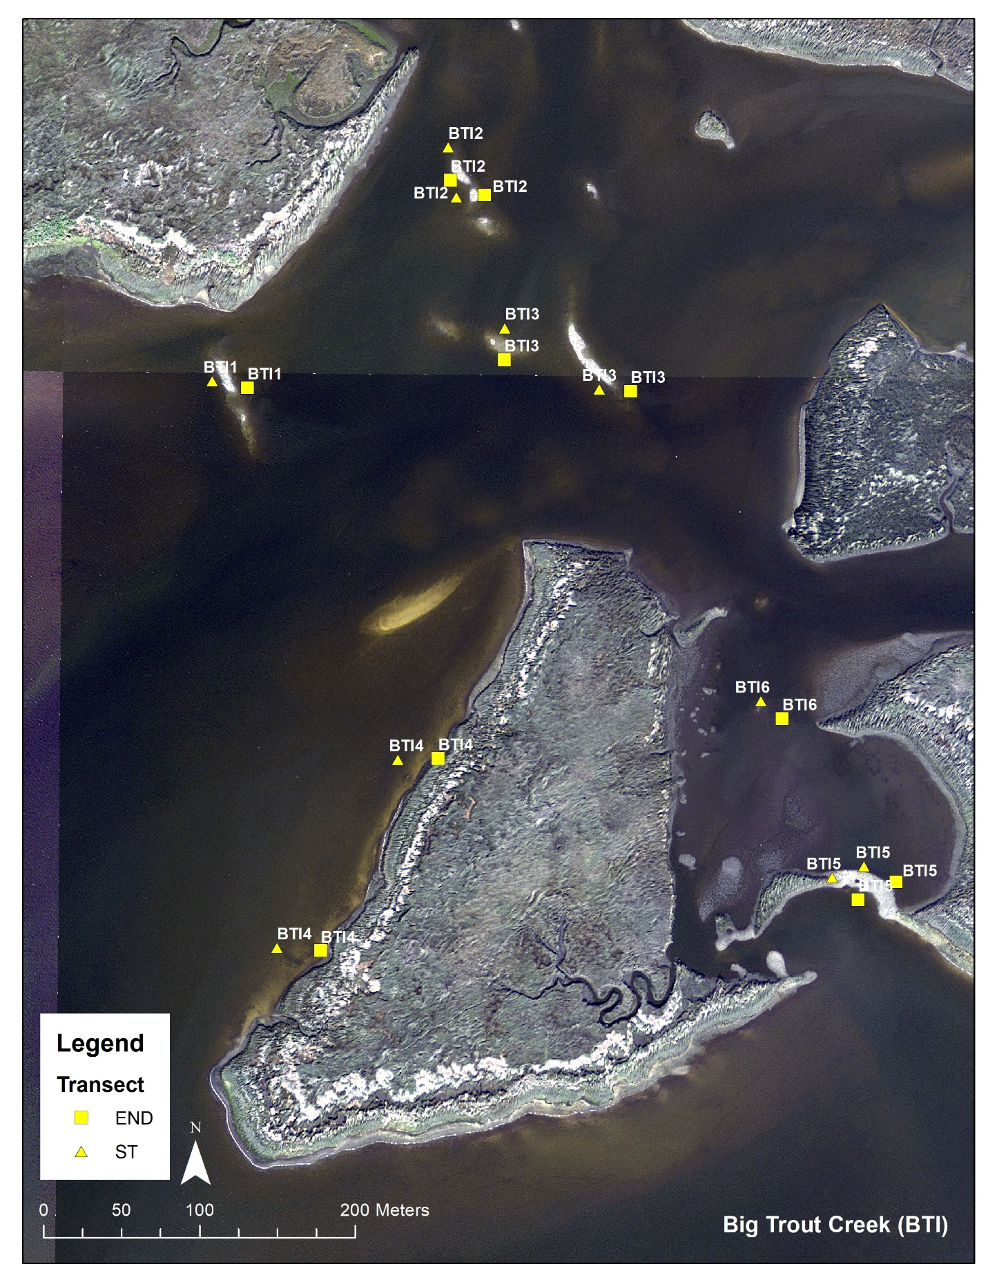

Figure 7: Big Trout Creek (BTI) transect distribution.

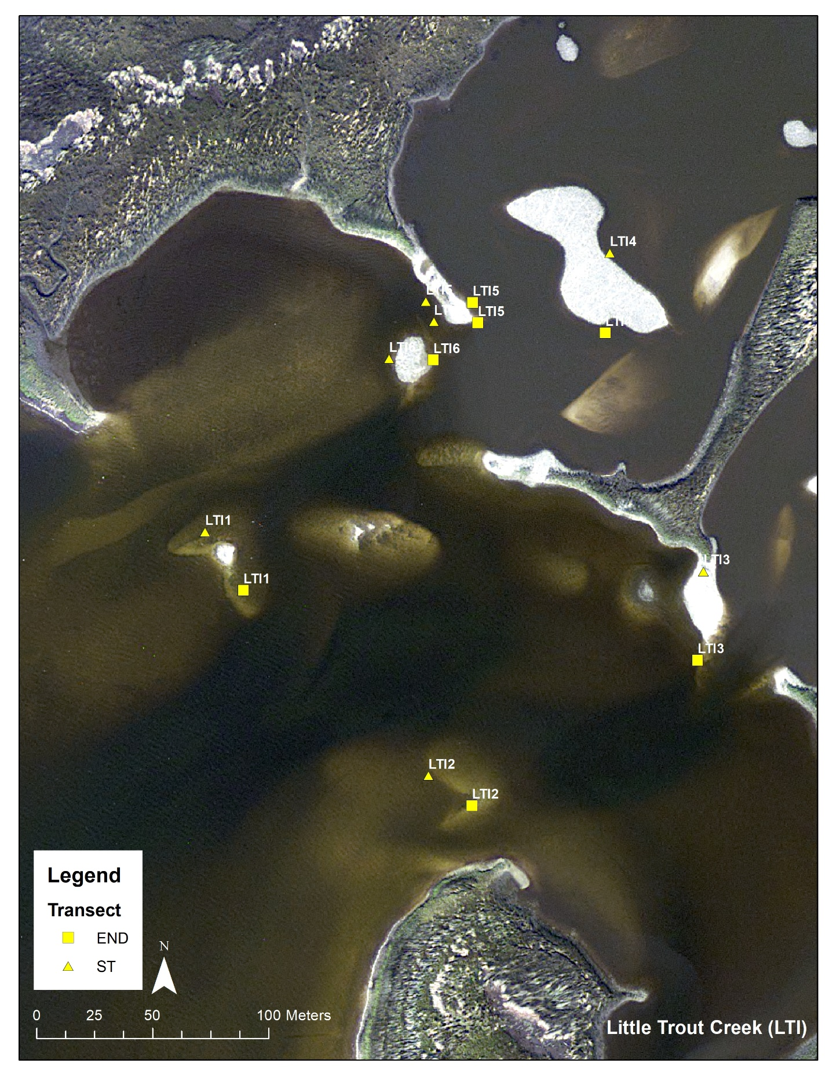

Figure 8: Little Trout Creek (LTI) transect distribution.

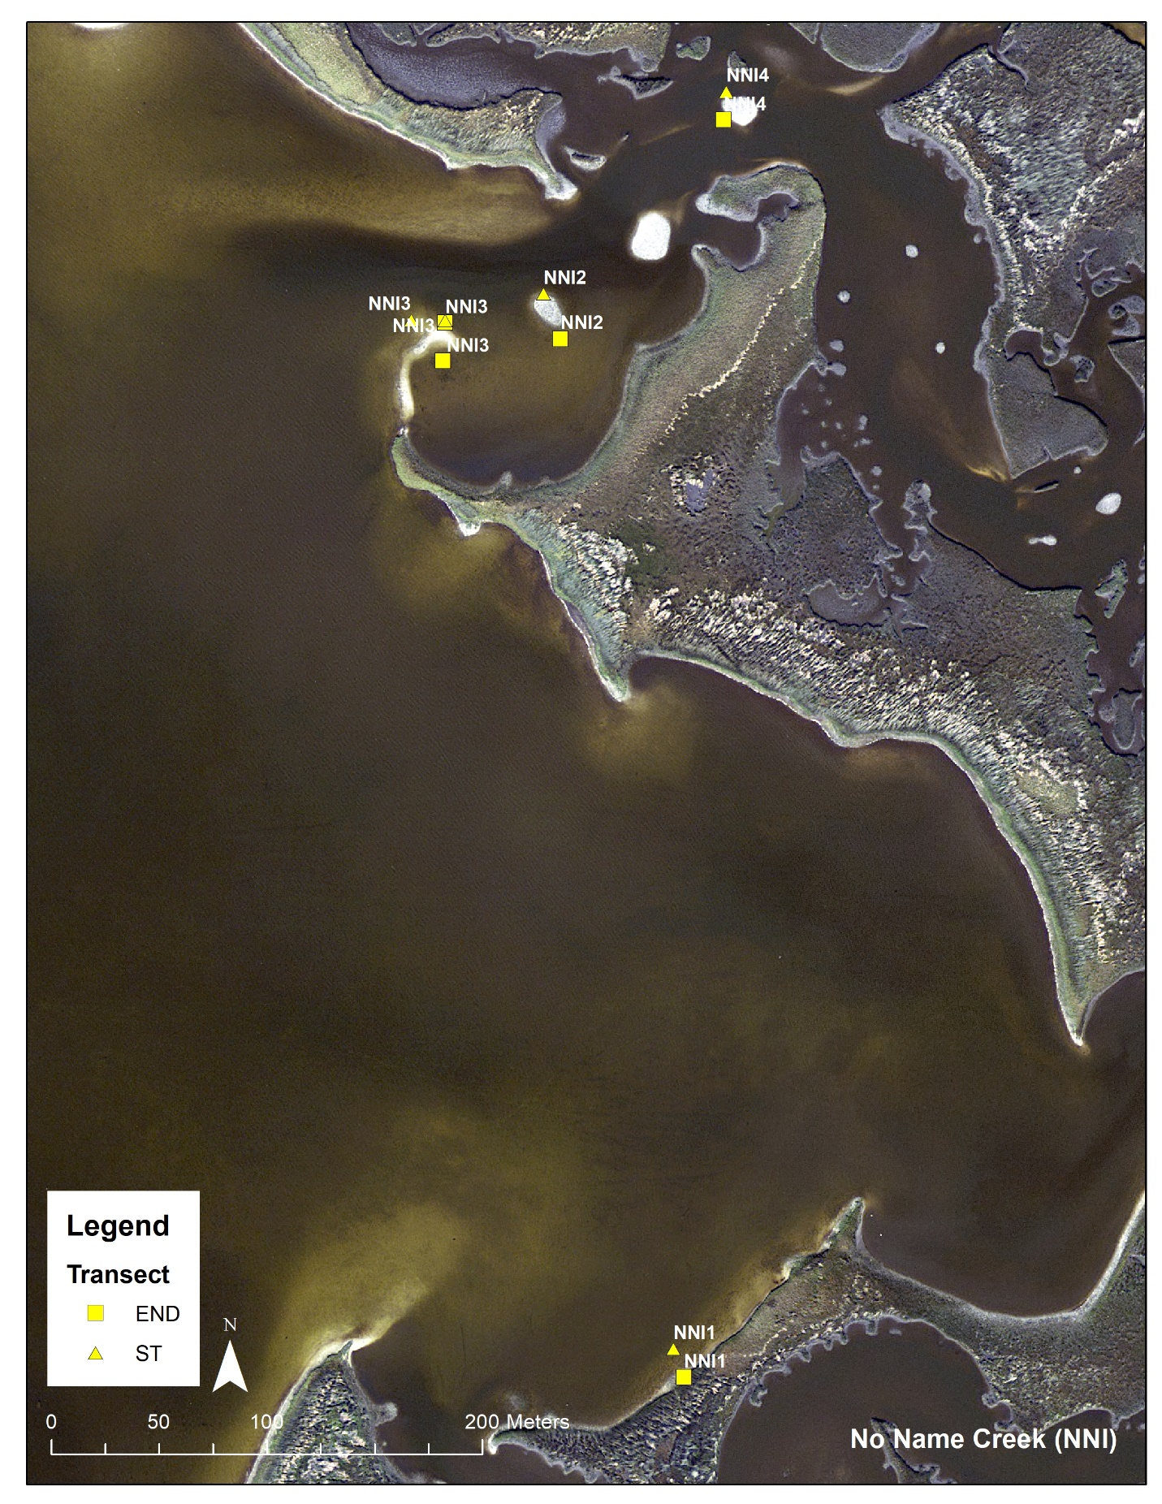

Figure 9: No-Name Creek (NNI) transect distribution.

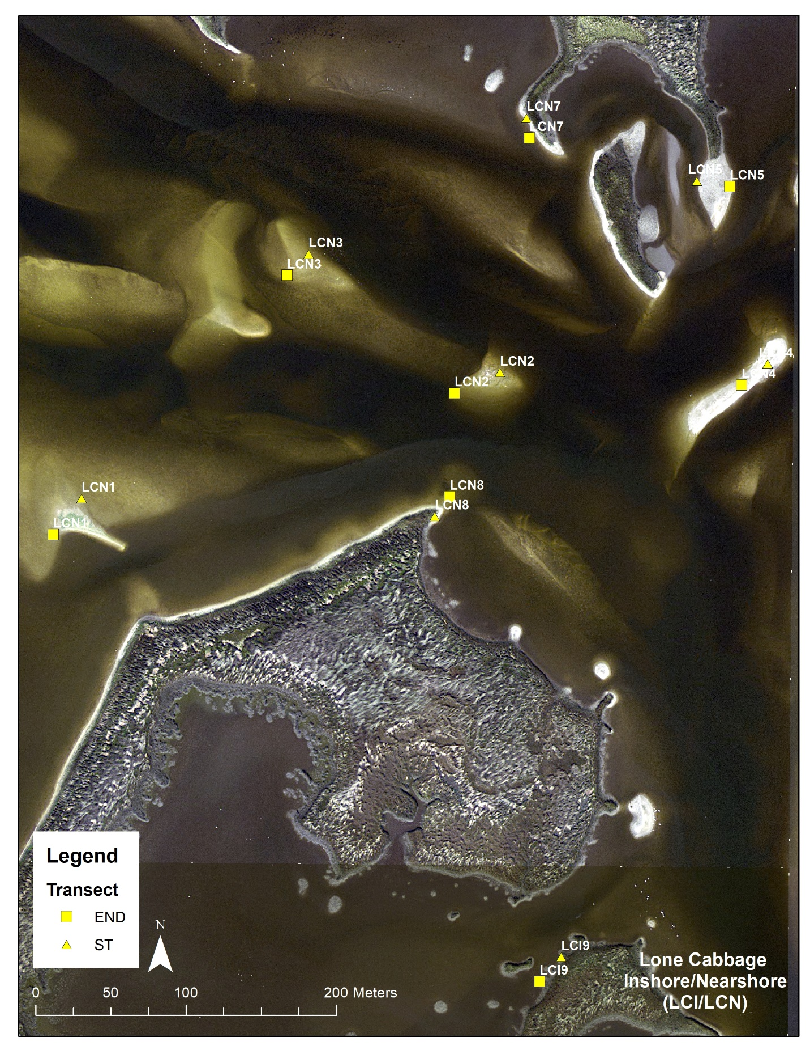

Figure 10: Lone Cabbage Nearshore (LCN)/Inshore (LCI) transect distribution.

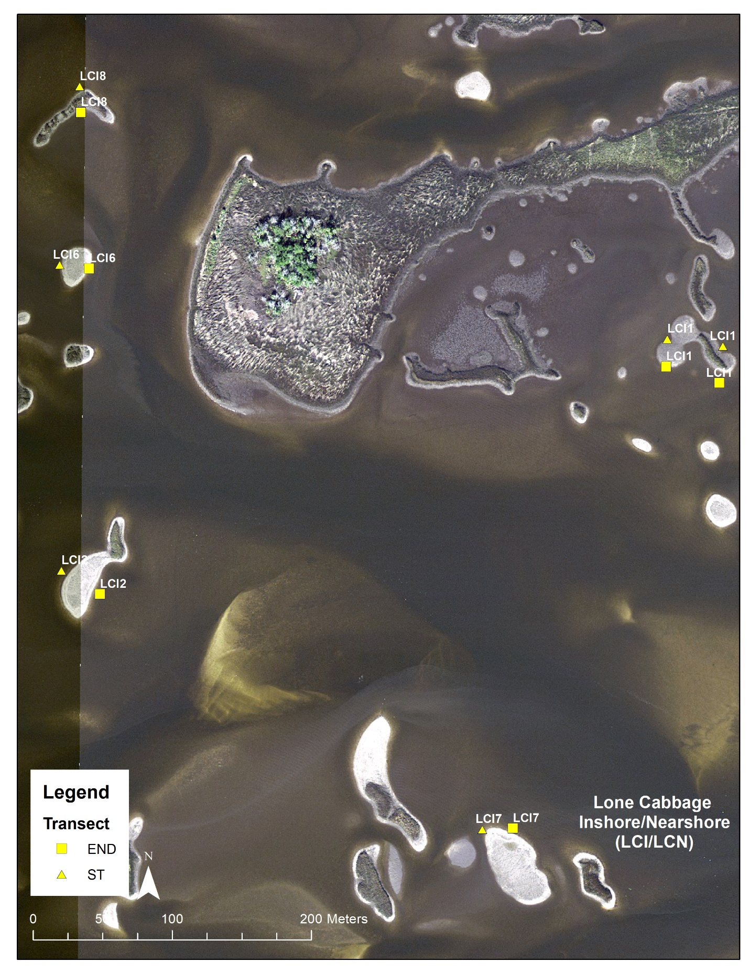

Figure 11: Lone Cabbage Nearshore (LCN)/Inshore (LCI) transect distribution (continued).

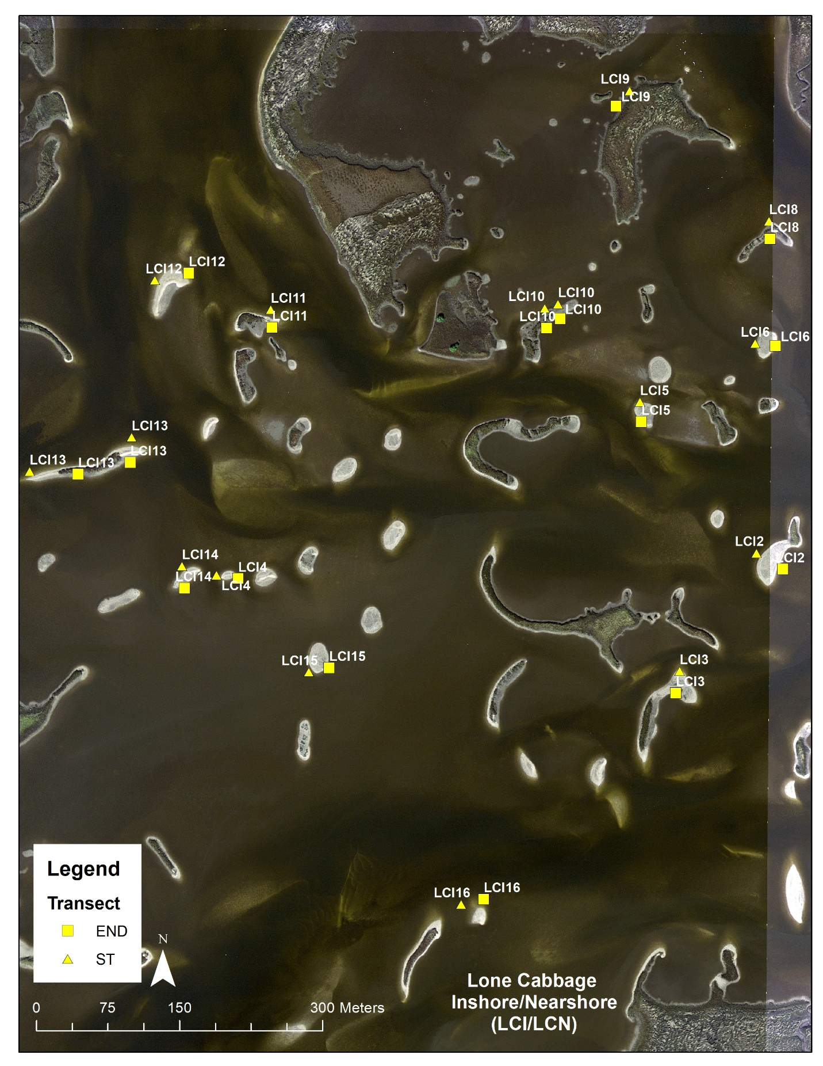

Figure 12: Lone Cabbage Nearshore (LCN)/Inshore (LCI) transect distribution (continued).

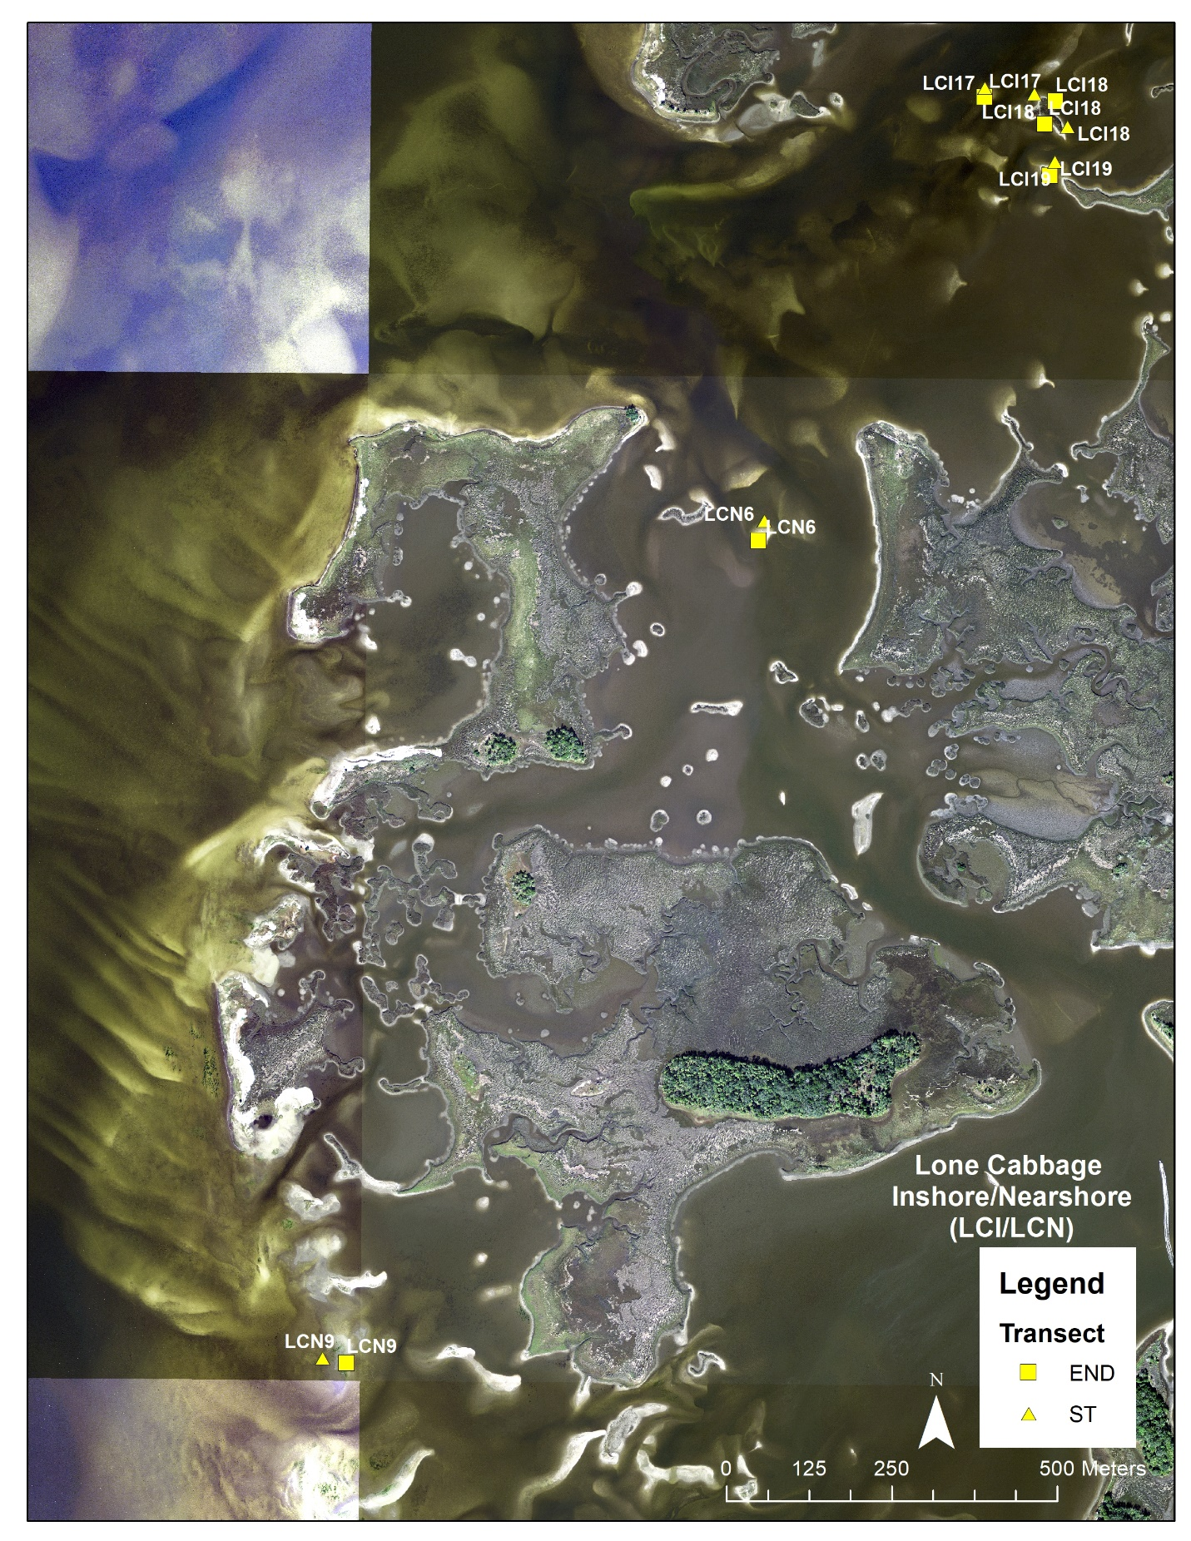

Figure 13: Lone Cabbage Nearshore (LCN)/Inshore (LCI) transect distribution (concluded).

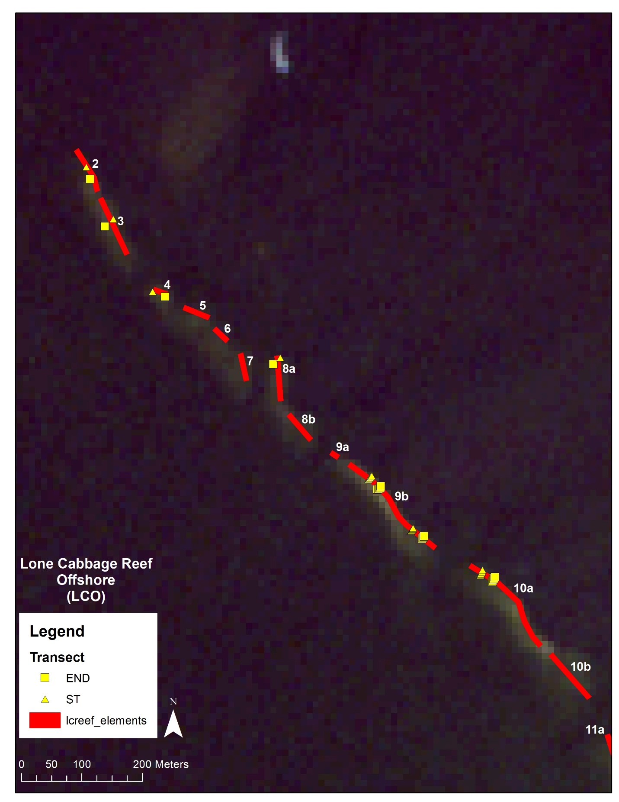

Figure 14: Lone Cabbage Reef (Offshore: LCO) transect distribution.

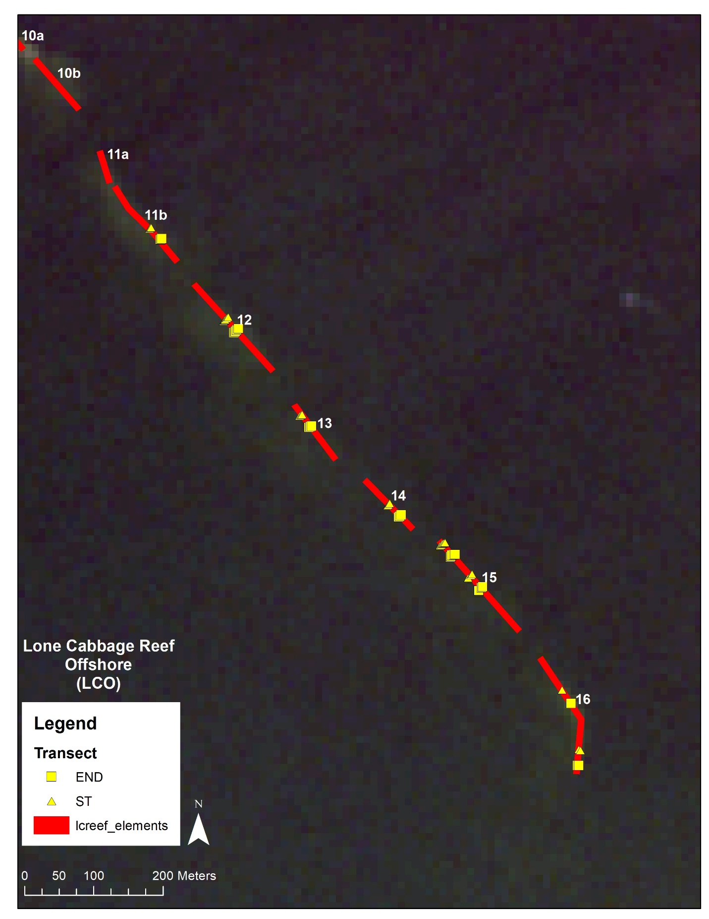

Figure 15: Lone Cabbage Reef (Offshore: LCO) transect distribution (continued).

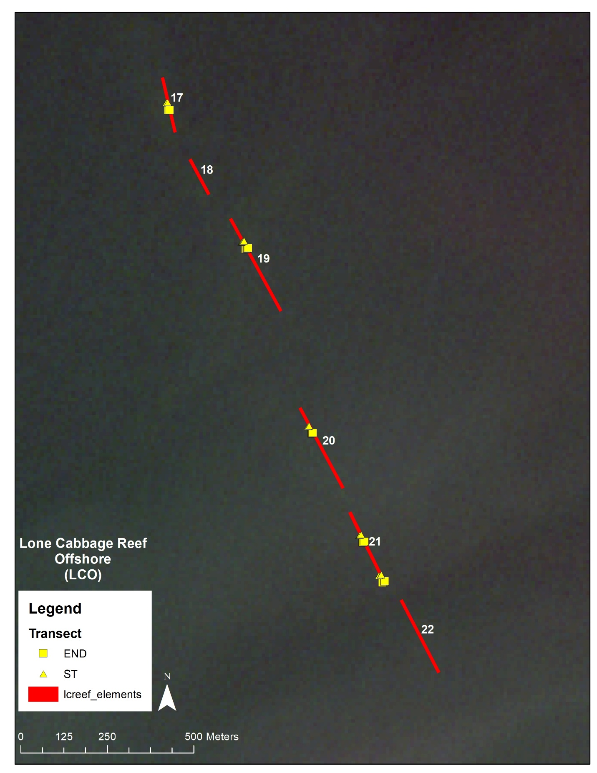

Figure 16: Lone Cabbage Reef (Offshore: LCO) transect distribution (concluded).

Table 3: Transect location data (UTM).

|  |  |  |  |  |
| --- | --- | --- | --- | --- |
| new_station | transect | type | easting | northing |
| BTI1 | 1 | TRAN_END | 297474.0 | 3239367.0 |
| BTI1 | 1 | TRAN_ST | 297451.4 | 3239371.3 |
| BTI2 | 1 | TRAN_END | 297604.5 | 3239500.2 |
| BTI2 | 1 | TRAN_ST | 297602.9 | 3239521.4 |
| BTI2 | 2 | TRAN_END | 297626.3 | 3239490.5 |
| BTI2 | 2 | TRAN_ST | 297608.2 | 3239489.2 |
| BTI3 | 1 | TRAN_END | 297639.0 | 3239384.8 |
| BTI3 | 1 | TRAN_ST | 297639.3 | 3239405.3 |
| BTI3 | 2 | TRAN_END | 297720.1 | 3239364.7 |
| BTI3 | 2 | TRAN_ST | 297700.0 | 3239366.0 |
| BTI4 | 1 | TRAN_END | 297596.5 | 3239129.1 |
| BTI4 | 1 | TRAN_ST | 297570.6 | 3239128.4 |
| BTI4 | 2 | TRAN_END | 297521.1 | 3239005.7 |
| BTI4 | 2 | TRAN_ST | 297493.1 | 3239007.7 |
| BTI5 | 1 | TRAN_END | 297866.4 | 3239038.4 |
| BTI5 | 1 | TRAN_ST | 297870.1 | 3239060.1 |
| BTI5 | 2 | TRAN_END | 297890.8 | 3239049.8 |
| BTI5 | 2 | TRAN_ST | 297849.7 | 3239052.7 |
| BTI6 | 1 | TRAN_END | 297817.6 | 3239154.6 |
| BTI6 | 1 | TRAN_ST | 297803.9 | 3239166.0 |
| LCI1 | 1 | TRAN_END | 299269.9 | 3235919.2 |
| LCI1 | 1 | TRAN_ST | 299270.6 | 3235939.1 |
| LCI1 | 2 | TRAN_END | 299308.1 | 3235907.4 |
| LCI1 | 2 | TRAN_ST | 299310.7 | 3235934.0 |
| LCI10 | 0 | TRAN_END | 298628.7 | 3236018.1 |
| LCI10 | 0 | TRAN_ST | 298612.3 | 3236029.5 |
| LCI10 | 1 | TRAN_END | 298614.6 | 3236008.4 |
| LCI10 | 2 | TRAN_ST | 298626.2 | 3236033.7 |
| LCI11 | 1 | TRAN_END | 298326.2 | 3236009.0 |
| LCI11 | 1 | TRAN_ST | 298325.0 | 3236027.9 |
| LCI12 | 1 | TRAN_END | 298239.0 | 3236066.0 |
| LCI12 | 1 | TRAN_ST | 298203.5 | 3236058.9 |
| LCI13 | 1 | TRAN_END | 298177.5 | 3235867.5 |
| LCI13 | 1 | TRAN_ST | 298179.0 | 3235894.1 |
| LCI13 | 2 | TRAN_END | 298122.6 | 3235855.2 |
| LCI13 | 2 | TRAN_ST | 298072.0 | 3235858.3 |
| LCI14 | 1 | TRAN_END | 298234.4 | 3235735.7 |
| LCI14 | 1 | TRAN_ST | 298231.7 | 3235759.0 |
| LCI15 | 1 | TRAN_END | 298386.0 | 3235652.1 |
| LCI15 | 1 | TRAN_ST | 298364.9 | 3235648.0 |
| LCI16 | 1 | TRAN_END | 298548.4 | 3235409.7 |
| LCI16 | 1 | TRAN_ST | 298524.8 | 3235404.6 |
| LCI17 | 1 | TRAN_END | 298248.9 | 3235223.2 |
| LCI17 | 1 | TRAN_ST | 298249.8 | 3235237.6 |
| LCI18 | 1 | TRAN_END | 298355.9 | 3235216.9 |
| LCI18 | 1 | TRAN_ST | 298324.4 | 3235228.5 |
| LCI18 | 2 | TRAN_END | 298339.7 | 3235182.8 |
| LCI18 | 2 | TRAN_ST | 298374.5 | 3235178.9 |
| LCI19 | 1 | TRAN_END | 298347.6 | 3235105.1 |
| LCI19 | 1 | TRAN_ST | 298355.3 | 3235126.0 |
| LCI2 | 1 | TRAN_END | 298862.4 | 3235755.6 |
| LCI2 | 1 | TRAN_ST | 298834.6 | 3235772.8 |
| LCI3 | 1 | TRAN_END | 298749.9 | 3235625.7 |
| LCI3 | 1 | TRAN_ST | 298753.9 | 3235648.9 |
| LCI4 | 1 | TRAN_END | 298290.7 | 3235745.8 |
| LCI4 | 1 | TRAN_ST | 298267.9 | 3235749.5 |
| LCI5 | 1 | TRAN_END | 298713.7 | 3235910.2 |
| LCI5 | 1 | TRAN_ST | 298712.5 | 3235931.2 |
| LCI6 | 1 | TRAN_END | 298854.7 | 3235989.7 |
| LCI6 | 1 | TRAN_ST | 298833.4 | 3235992.3 |
| LCI7 | 1 | TRAN_END | 299159.7 | 3235587.4 |
| LCI7 | 1 | TRAN_ST | 299137.6 | 3235586.7 |
| LCI8 | 1 | TRAN_END | 298848.7 | 3236101.8 |
| LCI8 | 1 | TRAN_ST | 298847.9 | 3236120.7 |
| LCI9 | 1 | TRAN_END | 298687.3 | 3236241.0 |
| LCI9 | 1 | TRAN_ST | 298701.6 | 3236257.4 |
| LCN1 | 1 | TRAN_END | 298363.2 | 3236538.3 |
| LCN1 | 1 | TRAN_ST | 298382.1 | 3236562.4 |
| LCN2 | 1 | TRAN_END | 298630.5 | 3236632.3 |
| LCN2 | 1 | TRAN_ST | 298660.9 | 3236646.1 |
| LCN3 | 1 | TRAN_END | 298519.1 | 3236710.7 |
| LCN3 | 1 | TRAN_ST | 298533.4 | 3236724.9 |
| LCN4 | 1 | TRAN_END | 298821.8 | 3236637.8 |
| LCN4 | 1 | TRAN_ST | 298839.2 | 3236651.9 |
| LCN5 | 1 | TRAN_END | 298814.1 | 3236769.8 |
| LCN5 | 1 | TRAN_ST | 298792.1 | 3236773.5 |
| LCN6 | 1 | TRAN_END | 297906.7 | 3234551.9 |
| LCN6 | 1 | TRAN_ST | 297915.9 | 3234582.8 |
| LCN7 | 1 | TRAN_END | 298680.6 | 3236802.1 |
| LCN7 | 1 | TRAN_ST | 298678.7 | 3236815.5 |
| LCN8 | 1 | TRAN_END | 298627.4 | 3236563.6 |
| LCN8 | 1 | TRAN_ST | 298617.4 | 3236550.5 |
| LCN9 | 1 | TRAN_END | 297283.3 | 3233307.9 |
| LCN9 | 1 | TRAN_ST | 297247.3 | 3233315.2 |
| LCO10A | 1 | TRAN_END | 295037.8 | 3238578.2 |
| LCO10A | 1 | TRAN_ST | 295018.3 | 3238589.1 |
| LCO10A | 2 | TRAN_END | 295038.6 | 3238579.6 |
| LCO10A | 2 | TRAN_ST | 295018.8 | 3238590.8 |
| LCO10A | 3 | TRAN_END | 295040.2 | 3238582.1 |
| LCO10A | 3 | TRAN_ST | 295020.2 | 3238593.3 |
| LCO10A | 4 | TRAN_END | 295040.8 | 3238583.4 |
| LCO10A | 4 | TRAN_ST | 295020.9 | 3238594.7 |
| LCO10A | 5 | TRAN_END | 295042.3 | 3238585.9 |
| LCO10A | 5 | TRAN_ST | 295021.9 | 3238597.4 |
| LCO11B | 1 | TRAN_END | 295316.2 | 3238196.9 |
| LCO11B | 1 | TRAN_ST | 295300.7 | 3238213.2 |
| LCO11B | 2 | TRAN_END | 295317.3 | 3238198.0 |
| LCO11B | 2 | TRAN_ST | 295302.0 | 3238214.2 |
| LCO11B | 3 | TRAN_END | 295318.4 | 3238198.8 |
| LCO11B | 3 | TRAN_ST | 295303.2 | 3238215.0 |
| LCO12 | 1 | TRAN_END | 295422.5 | 3238062.8 |
| LCO12 | 1 | TRAN_ST | 295407.8 | 3238079.7 |
| LCO12 | 2 | TRAN_END | 295423.6 | 3238063.6 |
| LCO12 | 2 | TRAN_ST | 295409.0 | 3238080.7 |
| LCO12 | 3 | TRAN_END | 295424.8 | 3238064.5 |
| LCO12 | 3 | TRAN_ST | 295410.1 | 3238081.8 |
| LCO12 | 4 | TRAN_END | 295427.1 | 3238066.5 |
| LCO12 | 4 | TRAN_ST | 295412.4 | 3238084.0 |
| LCO12 | 5 | TRAN_END | 295429.2 | 3238068.8 |
| LCO12 | 5 | TRAN_ST | 295414.7 | 3238085.6 |
| LCO13 | 1 | TRAN_END | 295531.4 | 3237925.9 |
| LCO13 | 1 | TRAN_ST | 295517.8 | 3237942.8 |
| LCO13 | 2 | TRAN_END | 295533.2 | 3237927.0 |
| LCO13 | 2 | TRAN_ST | 295519.8 | 3237943.8 |
| LCO13 | 3 | TRAN_END | 295535.0 | 3237928.0 |
| LCO13 | 3 | TRAN_ST | 295521.6 | 3237944.9 |
| LCO14 | 1 | TRAN_END | 295661.2 | 3237796.3 |
| LCO14 | 1 | TRAN_ST | 295644.9 | 3237813.1 |
| LCO14 | 2 | TRAN_END | 295662.9 | 3237797.5 |
| LCO14 | 2 | TRAN_ST | 295646.2 | 3237814.5 |
| LCO14 | 3 | TRAN_END | 295664.8 | 3237799.7 |
| LCO14 | 3 | TRAN_ST | 295648.3 | 3237816.6 |
| LCO15 | 1 | TRAN_END | 295735.8 | 3237738.5 |
| LCO15 | 1 | TRAN_ST | 295721.1 | 3237755.3 |
| LCO15 | 2 | TRAN_END | 295736.8 | 3237739.5 |
| LCO15 | 2 | TRAN_ST | 295723.0 | 3237756.4 |
| LCO15 | 3 | TRAN_END | 295738.1 | 3237741.6 |
| LCO15 | 3 | TRAN_ST | 295724.1 | 3237758.2 |
| LCO15 | 4 | TRAN_END | 295740.6 | 3237742.1 |
| LCO15 | 4 | TRAN_ST | 295726.3 | 3237759.1 |
| LCO15 | 5 | TRAN_END | 295742.6 | 3237742.4 |
| LCO15 | 5 | TRAN_ST | 295728.4 | 3237759.9 |
| LCO15 | 6 | TRAN_END | 295777.1 | 3237690.4 |
| LCO15 | 6 | TRAN_ST | 295761.7 | 3237708.5 |
| LCO15 | 7 | TRAN_END | 295781.1 | 3237694.5 |
| LCO15 | 7 | TRAN_ST | 295765.8 | 3237712.7 |
| LCO15 | 8 | TRAN_END | 295782.7 | 3237695.9 |
| LCO15 | 8 | TRAN_ST | 295767.4 | 3237714.3 |
| LCO16 | 1 | TRAN_END | 295910.4 | 3237527.2 |
| LCO16 | 1 | TRAN_ST | 295897.6 | 3237547.0 |
| LCO16 | 2 | TRAN_END | 295920.0 | 3237437.7 |
| LCO16 | 2 | TRAN_ST | 295922.0 | 3237461.0 |
| LCO16 | 3 | TRAN_END | 295921.8 | 3237437.7 |
| LCO16 | 3 | TRAN_ST | 295924.0 | 3237459.8 |
| LCO17 | 1 | TRAN_END | 295960.5 | 3236950.7 |
| LCO17 | 1 | TRAN_ST | 295955.2 | 3236972.9 |
| LCO17 | 2 | TRAN_END | 295964.5 | 3236951.7 |
| LCO17 | 2 | TRAN_ST | 295958.9 | 3236974.1 |
| LCO19 | 1 | TRAN_END | 296184.1 | 3236548.8 |
| LCO19 | 1 | TRAN_ST | 296172.5 | 3236569.4 |
| LCO19 | 2 | TRAN_END | 296186.0 | 3236550.0 |
| LCO19 | 2 | TRAN_ST | 296174.1 | 3236570.6 |
| LCO19 | 3 | TRAN_END | 296187.8 | 3236551.2 |
| LCO19 | 3 | TRAN_ST | 296175.7 | 3236571.7 |
| LCO19 | 4 | TRAN_END | 296189.5 | 3236551.9 |
| LCO19 | 4 | TRAN_ST | 296177.7 | 3236572.5 |
| LCO19 | 5 | TRAN_END | 296191.5 | 3236552.8 |
| LCO19 | 5 | TRAN_ST | 296179.4 | 3236573.2 |
| LCO2 | 1 | TRAN_END | 294371.3 | 3239244.3 |
| LCO2 | 1 | TRAN_ST | 294365.3 | 3239264.6 |
| LCO20 | 1 | TRAN_END | 296375.6 | 3236016.6 |
| LCO20 | 1 | TRAN_ST | 296364.1 | 3236036.6 |
| LCO20 | 2 | TRAN_END | 296377.5 | 3236017.3 |
| LCO20 | 2 | TRAN_ST | 296365.8 | 3236037.9 |
| LCO20 | 3 | TRAN_END | 296379.2 | 3236018.2 |
| LCO20 | 3 | TRAN_ST | 296367.8 | 3236038.7 |
| LCO21 | 1 | TRAN_END | 296522.6 | 3235701.3 |
| LCO21 | 1 | TRAN_ST | 296513.0 | 3235721.6 |
| LCO21 | 2 | TRAN_END | 296524.5 | 3235701.9 |
| LCO21 | 2 | TRAN_ST | 296514.6 | 3235722.3 |
| LCO21 | 3 | TRAN_END | 296528.2 | 3235703.7 |
| LCO21 | 3 | TRAN_ST | 296518.5 | 3235724.1 |
| LCO21 | 4 | TRAN_END | 296579.9 | 3235585.7 |
| LCO21 | 4 | TRAN_ST | 296569.6 | 3235605.4 |
| LCO21 | 5 | TRAN_END | 296585.3 | 3235588.1 |
| LCO21 | 5 | TRAN_ST | 296575.1 | 3235607.7 |
| LCO21 | 6 | TRAN_END | 296586.9 | 3235589.3 |
| LCO21 | 6 | TRAN_ST | 296576.6 | 3235608.4 |
| LCO3 | 1 | TRAN_END | 294395.8 | 3239165.9 |
| LCO3 | 1 | TRAN_ST | 294409.8 | 3239178.2 |
| LCO4 | 1 | TRAN_END | 294495.5 | 3239049.8 |
| LCO4 | 1 | TRAN_ST | 294475.0 | 3239058.0 |
| LCO8A | 1 | TRAN_END | 294675.1 | 3238937.9 |
| LCO8A | 1 | TRAN_ST | 294686.6 | 3238948.8 |
| LCO9B | 1 | TRAN_END | 294847.4 | 3238730.6 |
| LCO9B | 1 | TRAN_ST | 294832.6 | 3238747.7 |
| LCO9B | 2 | TRAN_END | 294849.4 | 3238731.3 |
| LCO9B | 2 | TRAN_ST | 294834.0 | 3238749.1 |
| LCO9B | 3 | TRAN_END | 294851.4 | 3238732.6 |
| LCO9B | 3 | TRAN_ST | 294835.5 | 3238750.4 |
| LCO9B | 4 | TRAN_END | 294852.9 | 3238734.0 |
| LCO9B | 4 | TRAN_ST | 294836.8 | 3238751.8 |
| LCO9B | 5 | TRAN_END | 294853.4 | 3238736.2 |
| LCO9B | 5 | TRAN_ST | 294838.3 | 3238753.0 |
| LCO9C | 1 | TRAN_END | 294921.6 | 3238648.8 |
| LCO9C | 1 | TRAN_ST | 294903.3 | 3238662.0 |
| LCO9C | 2 | TRAN_END | 294922.5 | 3238650.0 |
| LCO9C | 2 | TRAN_ST | 294904.0 | 3238663.1 |
| LCO9C | 3 | TRAN_END | 294923.3 | 3238651.4 |
| LCO9C | 3 | TRAN_ST | 294905.1 | 3238664.3 |
| LCO9C | 4 | TRAN_END | 294924.2 | 3238652.6 |
| LCO9C | 4 | TRAN_ST | 294906.0 | 3238665.5 |
| LCO9C | 5 | TRAN_END | 294925.0 | 3238653.5 |
| LCO9C | 5 | TRAN_ST | 294906.7 | 3238666.8 |
| LTI1 | 1 | TRAN_END | 298146.5 | 3238412.7 |
| LTI1 | 1 | TRAN_ST | 298130.0 | 3238437.9 |
| LTI2 | 1 | TRAN_END | 298245.2 | 3238319.9 |
| LTI2 | 1 | TRAN_ST | 298226.4 | 3238332.9 |
| LTI3 | 1 | TRAN_END | 298342.5 | 3238382.5 |
| LTI3 | 1 | TRAN_ST | 298345.0 | 3238420.9 |
| LTI4 | 1 | TRAN_END | 298302.7 | 3238523.6 |
| LTI4 | 1 | TRAN_ST | 298304.6 | 3238558.1 |
| LTI5 | 1 | TRAN_END | 298245.4 | 3238536.7 |
| LTI5 | 1 | TRAN_ST | 298225.2 | 3238537.2 |
| LTI5 | 2 | TRAN_END | 298247.7 | 3238527.9 |
| LTI5 | 2 | TRAN_ST | 298228.7 | 3238528.5 |
| LTI6 | 1 | TRAN_END | 298228.5 | 3238511.9 |
| LTI6 | 1 | TRAN_ST | 298209.3 | 3238512.5 |
| NNI1 | 1 | TRAN_END | 298536.2 | 3237214.9 |
| NNI1 | 1 | TRAN_ST | 298531.2 | 3237228.3 |
| NNI2 | 1 | TRAN_END | 298478.7 | 3237697.1 |
| NNI2 | 1 | TRAN_ST | 298470.9 | 3237718.3 |
| NNI3 | 1 | TRAN_END | 298425.1 | 3237704.7 |
| NNI3 | 1 | TRAN_ST | 298409.5 | 3237706.1 |
| NNI3 | 2 | TRAN_END | 298424.1 | 3237687.0 |
| NNI3 | 2 | TRAN_ST | 298425.2 | 3237705.8 |
| NNI4 | 1 | TRAN_END | 298554.4 | 3237798.8 |
| NNI4 | 1 | TRAN_ST | 298555.7 | 3237812.1 |

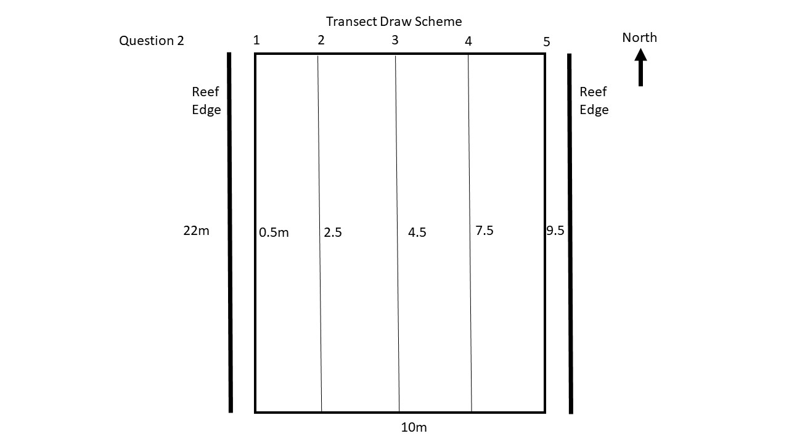

Figure 17: Question 2 transect orientation for Lone Cabbage Reef (Offshore: LCO)

**DATA MANAGEMENT:**

1. Scan datasheets (format: YYYYMMDD_transect_(Insert transect id)
2. Upload Photos (same as datasheet)
3. Upload GPS file (same as datasheet)
4. Dual-Entry spreadsheet (same as datasheet)
5. Save all files to T-drive
6. Upload raw data to Git
7. QA-QC script
8. Summary figures
9. Analyze to determine if protocol adjustment necessary